Data Due Diligence Project
DSE5004
June Lemieux

Project Summary

Introduction
This is a summary of data due diligence and feature engineering changes I performed as part of this project. I will refer to several Appendices which follow this summary.

Section II – Review data in Excel
The first exercise in this project involved reviewing the dataset. I used Excel to open the .csv file and get an overview of the dataset. I was able to view the breadth, depth, and completeness of the data. I saw a large variety of variables and many records that were full of data. I noticed quickly that Column 15 was useless and made a note to remove it. I scanned the customer records for missing data as these could be candidates for removal, but I didn’t find any. I also identified how I wanted to group the variables into broader categories. The broader categories and the variables associated with each can be found in Appendix A.

Section III - Review data in R
During the next exercise, I read the .csv file into R and could see R’s data type assignment to each value. For instance, I noticed that all the columns referencing dollar amounts were chr and included a dollar sign and a comma, so I made a note that these columns would need to be transformed to numbers to allow mathematical analysis. I also noted a few fields had been assigned as chr but had integers as values, and I suspected that these integers were indicative of some kind of regional grouping. For example, the Region column had values of 1 through 5 which probably had some kind of meaning. (NB: this work was done before I knew about the data dictionary.)

Section IV - Assumptions
By this point, I had accumulated a short list of assumptions and questions, including:
- Values in CommuteTime are expressed in minutes.
- Values in CardTenure are expressed in months.
- Values in PhoneCoTenure are expressed in months.
- Values in EmploymentLength are expressed in years.
- Value of “Yes” in LoanDefault means the customer has defaulted on a loan in the past; “No” means they had not defaulted.
- Values in DebtToIncomeRatio are monthly debt payments divided by monthly income with a percent as a result.
- What units are the CreditDebt and OtherDebt columns? Percentages? Of what to what?
- DebtToIncomeRatio can be categorized by an industry standard (Wells Fargo, 2024)
- TownSize can be categorized by a U.S. Census standard (U.S. Census, 2023)

Section V - Creating new variables.
During this part of the project, I had identified some ideas about how I might want to use the data in a future marketing segmentation analysis for a telecom company. I used R to transform existing variables into new variables that satisfied some of the goals I established. I have listed each new variable in Appendix B as well as a basic description for the new variable’s purpose. There are ten (10) descriptions and I have explained those in Appendix C.

Section VI Creating plots.
In this part of the project, I experimented with many different types of plots using R, Tableau and Looker Studio. I selected several graphs from R and Tableau and present them in Appendix . In my opinion, each of these software programs can make a visualization look great, but each program has functionality that is hard to understand and implement. Initially I produced the same graphs in all three programs and chose the ‘better’ one for the summary. “Better” is really, really subjective. I was using graphs to show me the story behind the data, and I created too many graphs to include in a report.

Conclusion
This project provided opportunities to practice data wrangling, data due diligence, and visualization skills. Having a data dictionary was very helpful for the data wrangling and due diligence. Trialing three different visualization packages was interesting and challenging. I’m interested to see how this project fits into the next one.

Appendix A
Provide categories for all variables.

Geography
Original Variable | Added Variables
Region | Region_cat
TownSize | TownSize_nona

Demographics
Original Variable | Added Variables
Gender
Age
EducationYears
MaritalStatus
HouseholdSize
CommuteTime | CommuteTime_nona
PoliticalParty
Votes
ActiveLifestyle

EmploymentInfo
Original Variable | No new variables created for this group
JobCategory
UnionMember
EmploymentLength
Retire

Financial
Original Variable | Added Variables
HHIncome | HHIncome_usd
DebtToIncomeRatio
CreditDebt
OtherDebt
LoanDefault
HomeOwner
CarsOwned
CarOwnership | CarOwnership_cat
CarBrand | CarBrand_cat
CarValue | CarValue_usd
CreditCard
CardTenure
CardSpendMonth | CardSpendMonth_usd
CardItemsMonthly
 | TotalDebt_usd
 | HHIncGroup
 | DTICategory_usd

Pets
Original Variable | No new variables created for this group
NumberPets
NumberCats
NumberDogs
NumberBirds

Telecom Features
Original Variable | Added Variables
PhoneCoTenure
VoiceLastMonth | VoiceLastMonth_usd
VoiceOverTenure | VoiceOverTenure_usd
EquipmentRental
EquipmentLastMonth | EquipmentLastMonth_usd
EquipmentOverTenure | EquipmentOverTenure_usd
CallingCard | CallingCard_tf
WirelessData | WirelessData_tf
DataLastMonth | DataLastMonth_usd
DataOverTenure | DataOverTenure_usd
Multiline | Multiline_tf
VM | VM_tf
Pager | Pager_tf
Internet | Internet_cat, Internet_tf
CallerID | CallerID_tf
CallWait | CallWait_tf
CallForward | CallForward_tf
ThreeWayCalling | ThreeWayCalling_tf
NewsSubscriber | NewsSubscriber_tf
 | TelecomFeatureCount
 | TotTelecomLastMonth_usd
 | TotTelecomOverTenure_usd

Telecom Behavior
Original Variable | No new variables created for this group
TVWatchingHours
OwnsPC
OwnsMobileDevice
OwnsGameSystem
OwnsFax

Appendix B
New Variable Explanations
CallerID_tf | Copy of existing variable with '_tf' appended to end of name to facilitate calculation of TelecomFeatureCount
CallForward_tf | Copy of existing variable with '_tf' appended to end of name to facilitate calculation of TelecomFeatureCount
CallingCard_tf | Copy of existing variable with '_tf' appended to end of name to facilitate calculation of TelecomFeatureCount
CallWait_tf | Copy of existing variable with '_tf' appended to end of name to facilitate calculation of TelecomFeatureCount
CarBrand_cat | Change from '-1' value to 'NoCar' to allow easier comparison with other values in variable
CardSpendMonth_usd | Changes char value to num value and removes unhelpful chars
CarOwnership_cat | Change from '-1' value to 'NoCar' to allow easier comparison with other values in variable
CarValue_usd | Changes char value to num value and removes unhelpful chars
CommuteTime_nona | Changed NA records to ' based on theory that the single customer had no car
DataLastMonth_usd | Changes char value to num value and removes unhelpful chars
DataOverTenure_usd | Changes char value to num value and removes unhelpful chars
DTICategory_usd | Changes char value to num value and removes unhelpful chars
EquipmentLastMonth_usd | Changes char value to num value and removes unhelpful chars
EquipmentOverTenure_usd | Changes char value to num value and removes unhelpful chars
HHIncGroup | Assigned categories to ranges of HHIncome (50K increments)
HHIncome_usd | Changes char value to num value and removes unhelpful chars
Internet_cat | Converted non-Y/N data to Yes (only a few records impacted)
Internet_tf | Copy of existing variable with '_tf' appended to end of name to facilitate calculation of TelecomFeatureCount
Multiline_tf | Copy of existing variable with '_tf' appended to end of name to facilitate calculation of TelecomFeatureCount
NewsSubscriber_tf | Copy of existing variable with '_tf' appended to end of name to facilitate calculation of TelecomFeatureCount
Pager_tf | Copy of existing variable with '_tf' appended to end of name to facilitate calculation of TelecomFeatureCount
Region_cat | Substituted '1', '2', etc to meaningful text
TelecomFeatureCount | Count of telecom features (variables with '_tf' appended) that each customer purchases
ThreeWayCalling_tf | Copy of existing variable with '_tf' appended to end of name to facilitate calculation of TelecomFeatureCount
TotalDebt_usd | Sum of CreditDebt and OtherDebt as a num value
TotTelecomLastMonth_usd | Changes char value to num value and removes unhelpful chars
TotTelecomOverTenure_usd | Changes char value to num value and removes unhelpful chars
TownSize_nona | Changed NA records to '1' (only a few records affected) and then substituted '1', '2', etc to meaningful text
VM_tf | Copy of existing variable with '_tf' appended to end of name to facilitate calculation of TelecomFeatureCount
VoiceLastMonth_usd | Changes char value to num value and removes unhelpful chars
VoiceOverTenure_usd | Changes char value to num value and removes unhelpful chars
WirelessData_tf | Copy of existing variable with '_tf' appended to end of name to facilitate calculation of TelecomFeatureCount

Appendix C
Expanded definitions of the descriptions identified in Appendix B
Assigned categories to ranges of HHIncome (50K increments). This description relates to the creation of the HHIncGroup categorical variable to assign a customer’s HHIncome value to a grouping of 50K increments.
Change from '-1' value to 'NoCar' to allow easier comparison with other values in variable. This description explains changing CarBrand_cat and CarOwnership_cat from an integer chr datapoint to a chr value that can be compared more easily with the other values those two columns.
Changed NA records to 0 based on theory that the single customer had no car. This description explains changing the NA records in CommuteTime to zero. There were very few records like this so I didn’t feel the change would impede analysis.
Changed NA records to '1' (only a few records affected) and then substituted '1', '2', etc to meaningful text. This description explains changing the values in TownSize from NA to ‘1’ and then changing all the integer chr values to something more meaningful based on the provided data dictionary.
Changes char value to num value and removes unhelpful chars. All variables with dollar amounts were initially set as chr by R. Additionally, there were ‘$’ and ‘,’ characters present. The new variables are numeric with no special characters. This change will facilitate mathematical analyses.
Converted non-Y/N data to Yes (only a few records impacted). The Internet variable initially contained some values that were not “Yes” nor “No”. I changed those values to be “Yes”, which affected just a few records but would facilitate future analysis.
Copy of existing variable with '_tf' appended to end of name to facilitate calculation of TelecomFeatureCount. I determined that there were several variables that identified whether or not a customer had purchased those telecom products/services. I appended the phrase ‘_tf’ to the end of these variables so that establishing the count of the purchases by customer would be easier to accomplish in R.
Count of telecom features (variables with '_tf' appended) that each customer purchases. TelecomFeatureCount is a new variable storing the count of purchased telecom products/services for each customer.
Substituted '1', '2', etc to meaningful text. The Region variable was initially integers. Based on information provided in the data dictionary, I changed these integer chr values to the geographical breakdown identified for Region.
Sum of CreditDebt and OtherDebt as a num value. The variable, TotalDebt_usd, is the sum of CreditDebt and OtherDebt as a numeric value.

Appendix D
Graphs.

Count By Age. Univariate. Created in R.
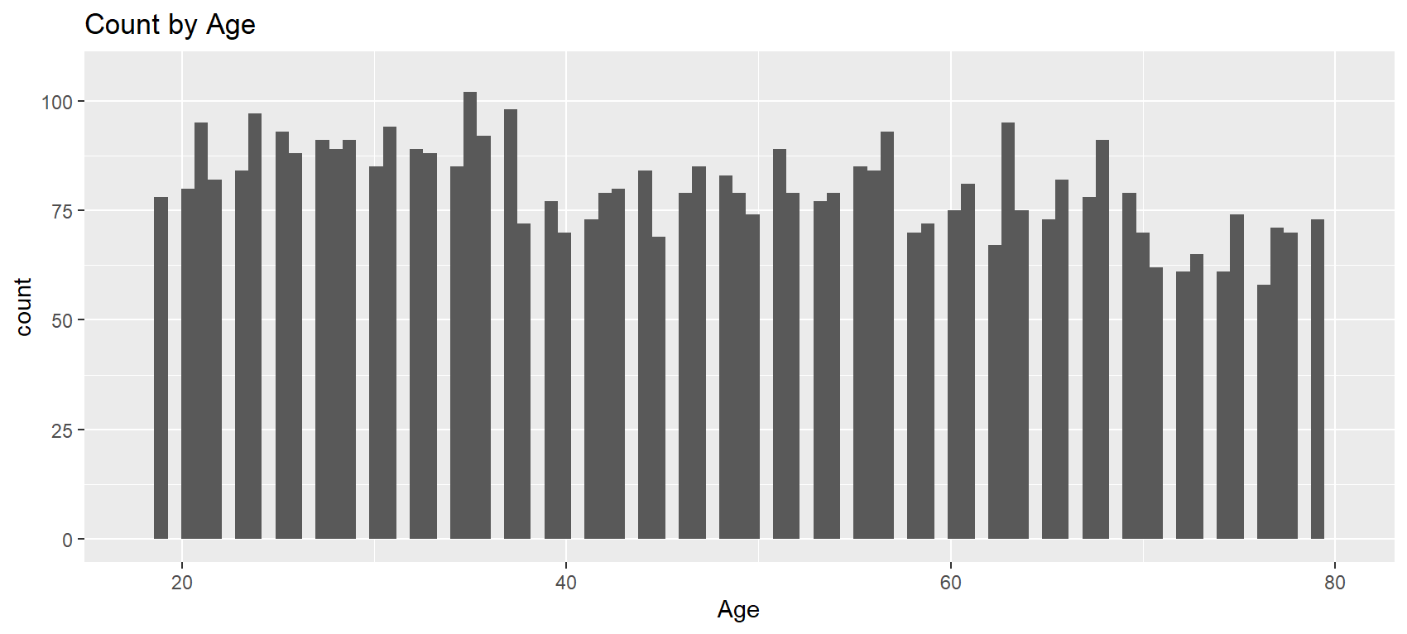

Count of Telecom Features Purchased. Univariate. Created in R.
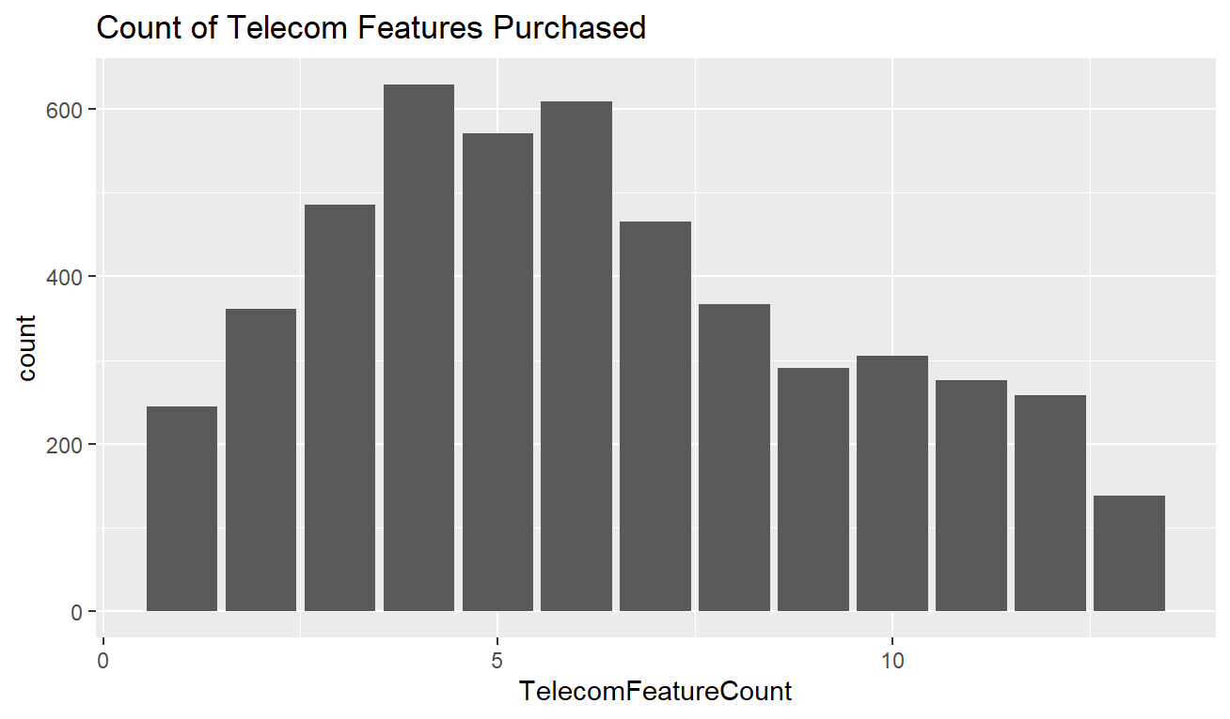

Count of customers based on DebToIncome rating. Univariate. Created in R.
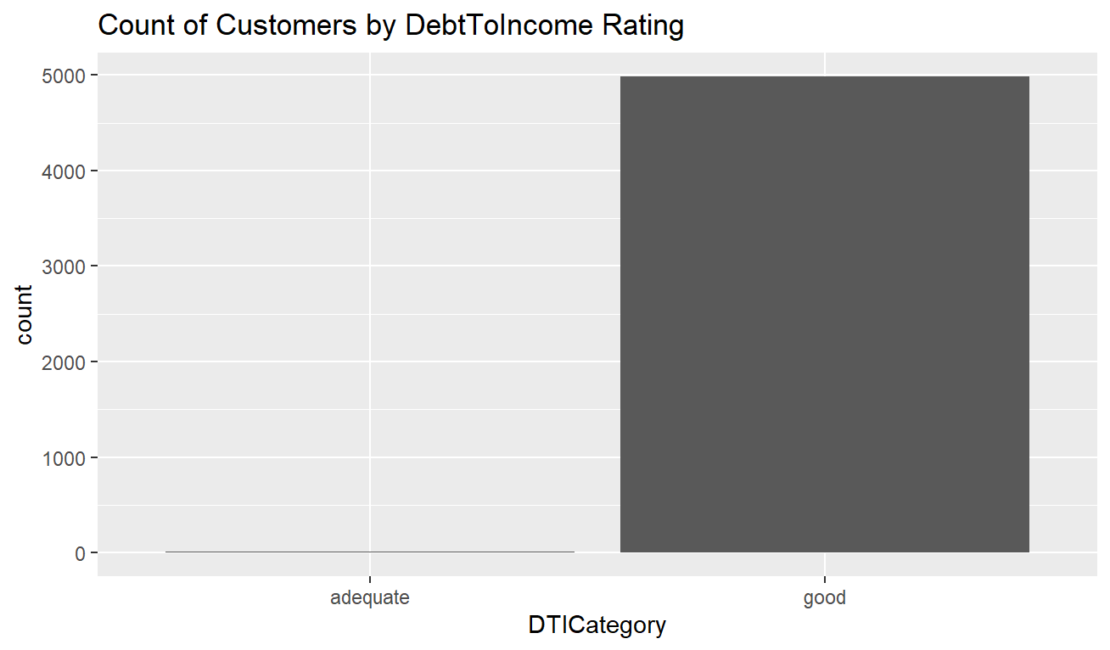

Count of customers based on Town Size. Univariate. Created in Tableau.
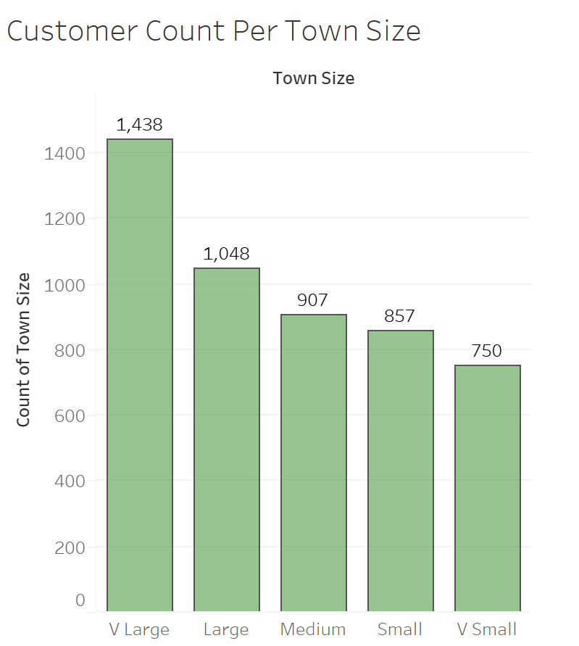

Distribution of customer by household income. Univariate. Created in Tableau.
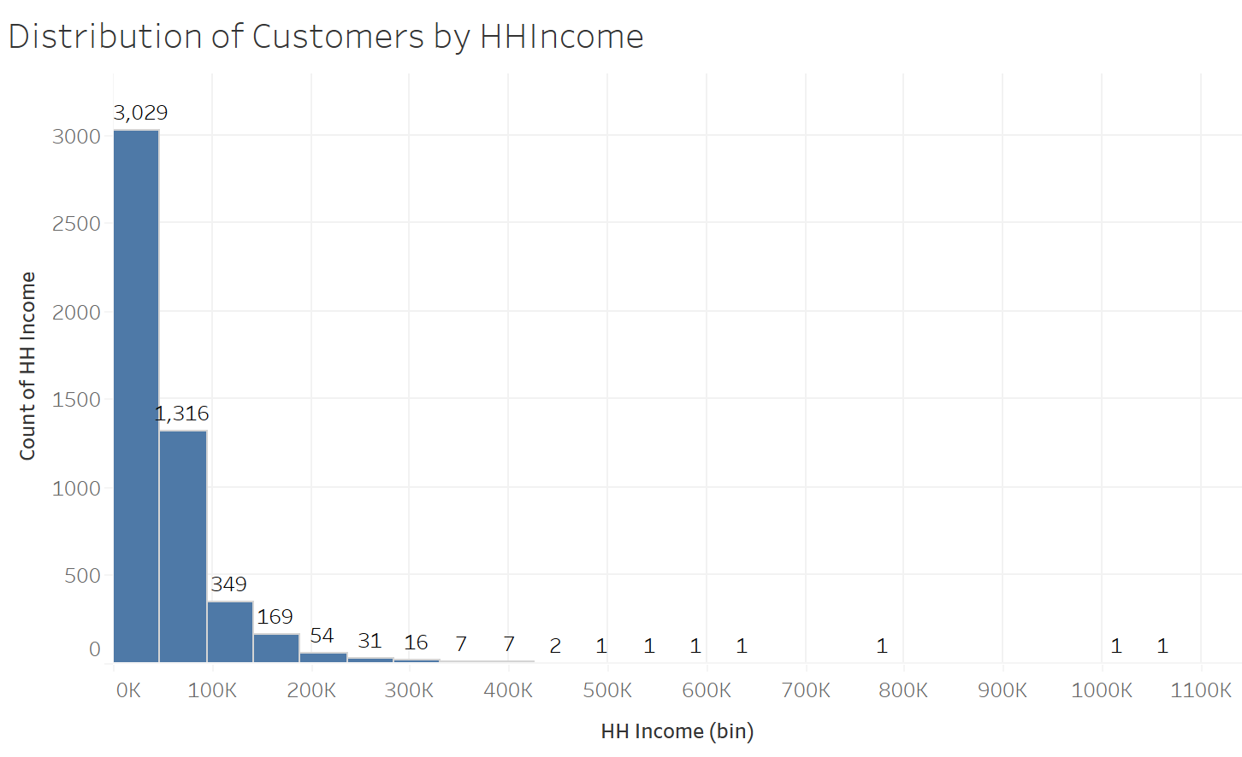

Distribution of credit card types. Univariate. Created in Tableau.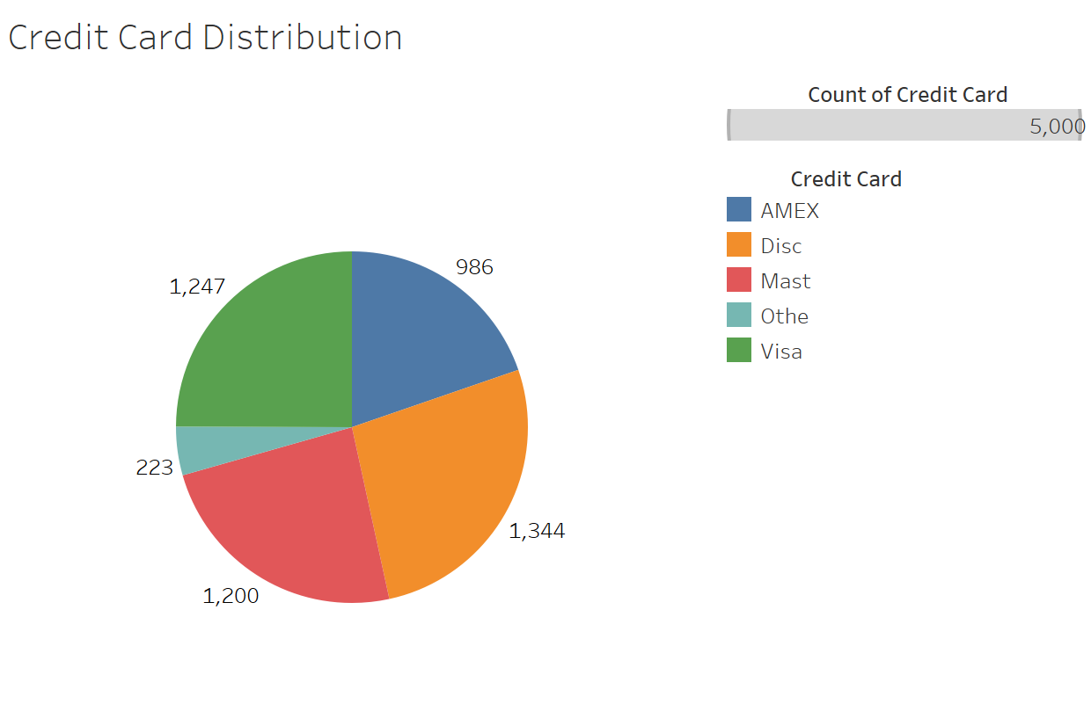

Count by Region and Job Category. Multivariate. Created in Tableau.
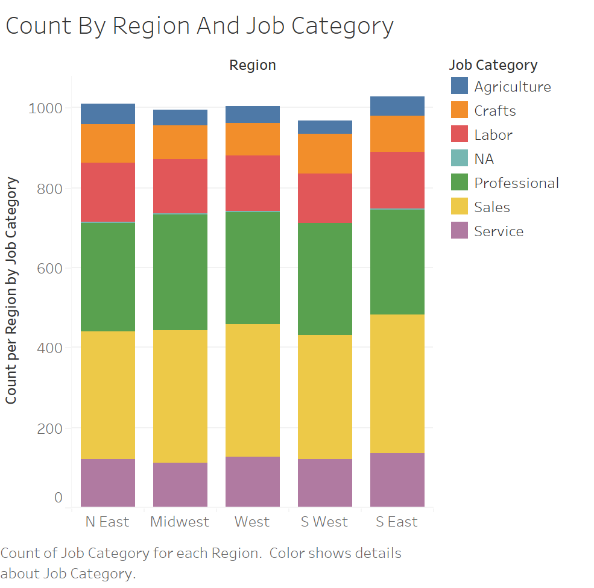

Household Income Distribution by Age. Multivariate. Created in Tableau.
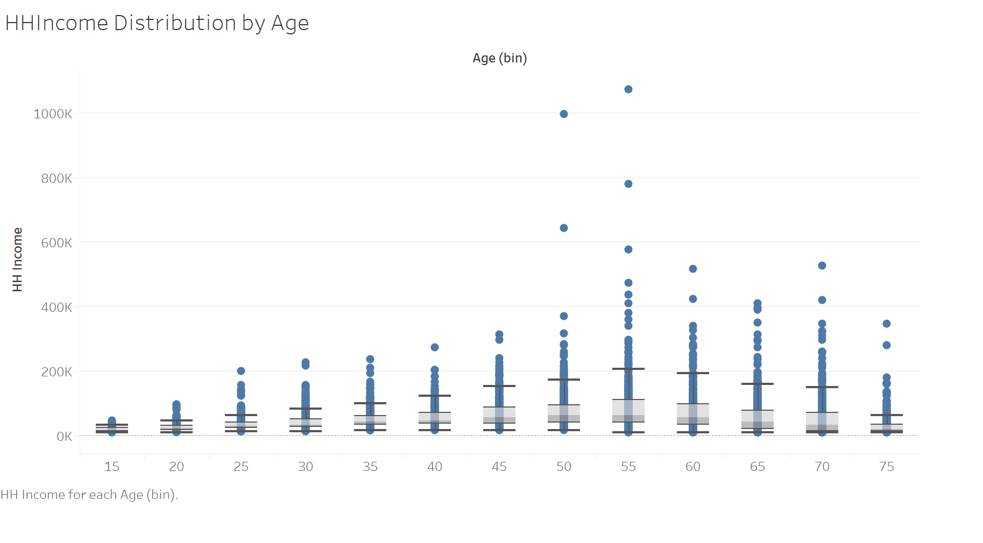

Customers’ Feature Purchases based on Househould income grouping. Multivariate. Created in R.

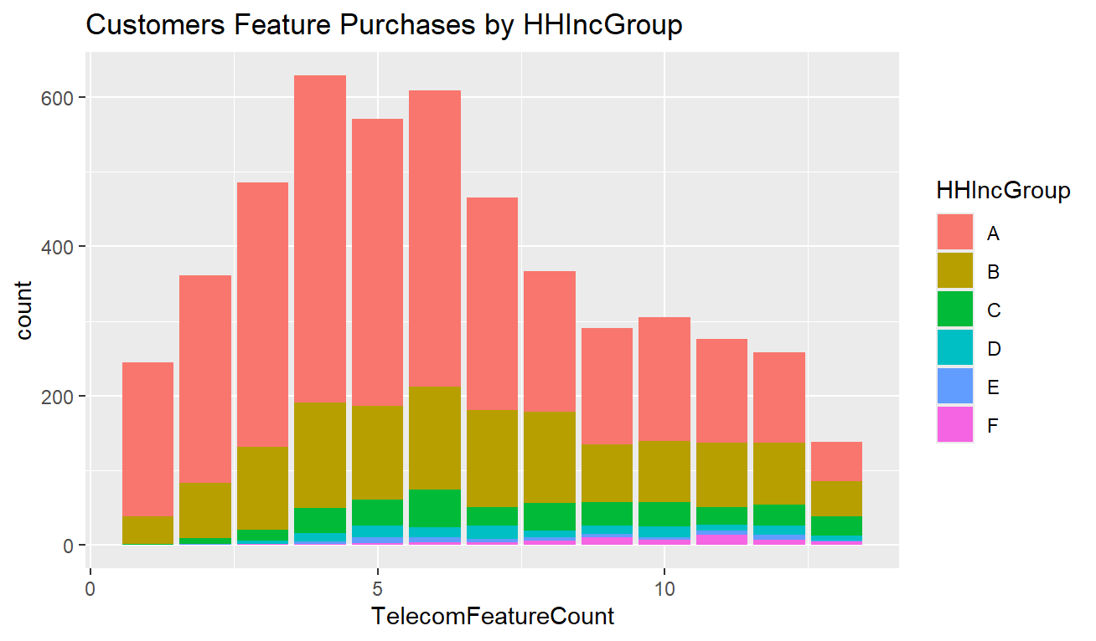

Credit card spending vs. telecom spending with a subgrouping of Househould Income groupings.
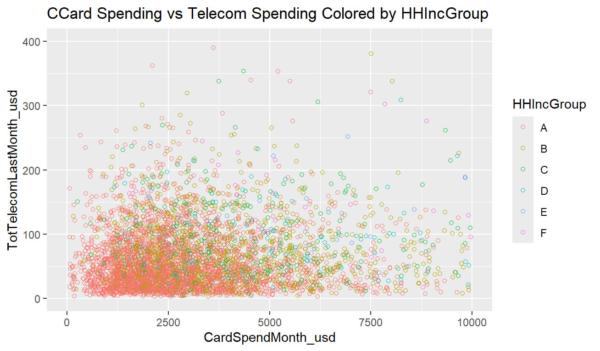

Credit card spending vs. telecom spending with a subgrouping of regional categories.
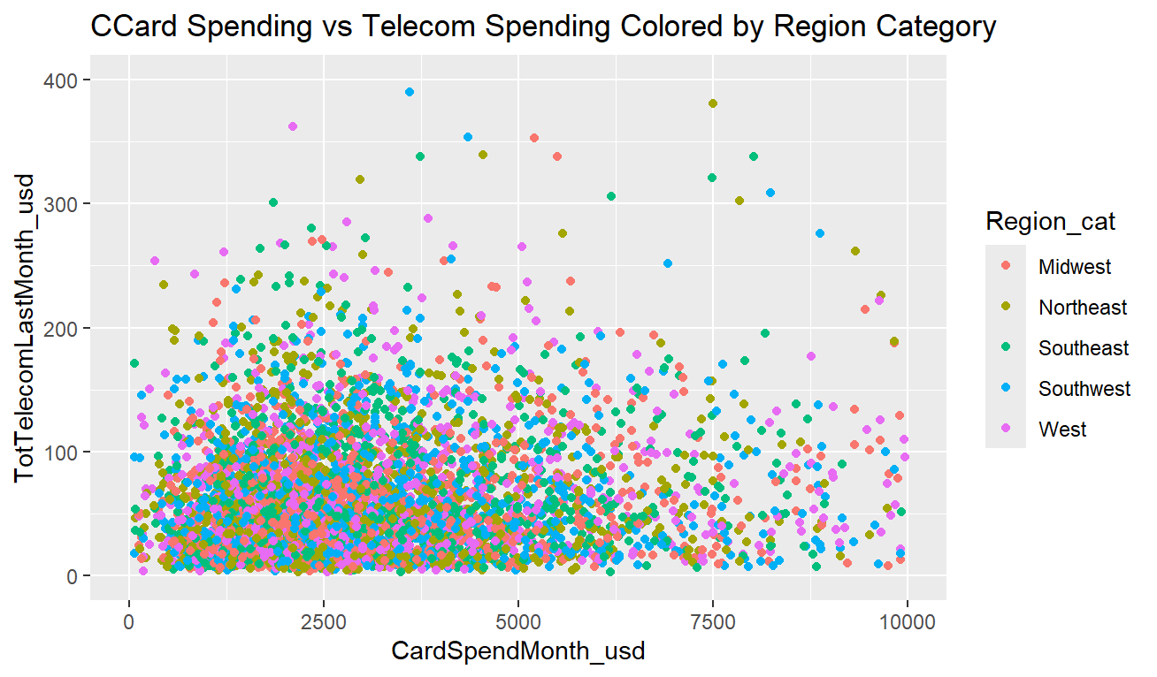

References
U.S. Census. (2023). U.S. Census Bureau. Retrieved from Texas Continues to Top the Charts With Fastest-Growing Cities: https://www.census.gov/newsroom/press-releases/2023/subcounty-metro-micro-estimates.html
Wells Fargo. (2024). Wells Fargo. Retrieved from What is a Good Debt-to-Income Ratio?: https://www.wellsfargo.com/goals-credit/smarter-credit/credit-101/debt-to-income-ratio/understanding-dti/

